Fid.01

|  |  |
| --- | --- |
| Code | F.01 |
| Name | LogIn |
| Type | Functional |
| Critically | High |
| Input | Email,Password |
| Output | Redirect to specified web pages |
| Description | The user input his/her email and password to check them in the database |
| Priority | 10/10 |
| Expected risk | Database size, bugs,wrong email or password |
| Preconditions | Open website |
| Post-condition | Fill session with the user data |
| Dependencies | none |

Fid.02

|  |  |
| --- | --- |
| Code | F.02 |
| Name | Encrypt |
| Type | Functional |
| Critically | High |
| Input | Password |
| Output | Encrypted password |
| Description | The function get the password of the user and encrypt it for security |
| Priority | 10/10 |
| Expected risk | Database size, bugs |
| Preconditions | none |
| Post-condition | none |
| Dependencies | Fid.01 |

Fid.03

|  |  |
| --- | --- |
| Code | F.03 |
| Name | Decrypt |
| Type | Functional |
| Critically | High |
| Input | Password |
| Output | None |
| Description | The inputed password should be decrypted to see of it match in the database |
| Priority | 10/10 |
| Expected risk | Database size, bugs |
| Preconditions | none |
| Post-condition | None |
| Dependencies | Fid.02,Fid.01 |

Fid.04

|  |  |
| --- | --- |
| Code | F.04 |
| Name | AddURL |
| Type | Functional |
| Critically | High |
| Input | ArrayOfLinks |
| Output | Urls added to the database according to the member id |
| Description | The admin adds the urls according to the member |
| Priority | 10/10 |
| Expected risk | Database size, bugs |
| Preconditions | User must be loggedin with admin account type |
| Post-condition | URLS added to the new account according to account type |
| Dependencies | Fid.01 |

Fid.05

|  |  |
| --- | --- |
| Code | F.05 |
| Name | EditPassword |
| Type | Functional |
| Critically | High |
| Input | Email |
| Output | New password added to the same account |
| Description | The user must enter the new password |
| Priority | 10/10 |
| Expected risk | Database size, bugs |
| Preconditions | User must be loggedin |
| Post-condition | The password should be encryoted in the database |
| Dependencies | Fid.01,Fid.02 |

Fid.06

|  |  |
| --- | --- |
| Code | Fid.06 |
| Name | CreateDownloadLink |
| Type | Functional |
| Critically | High |
| Input | none |
| Output | Download Link is Created |
| Description | The System creates a download link to other users to be downloaded the users must be in the same project |
| Priority | 10/10 |
| Expected risk | Database size, bugs |
| Preconditions | User must be loggedin |
| Post-condition | None |
| Dependencies | Fid.01 |

Function id.07

|  |  |
| --- | --- |
| Code | F.07 |
| Name | ViewTask |
| Type | Functional |
| Critically | High |
| Input | None |
| Output | Show task information |
| Description | Read information from the database |
| Priority | 10/10 |
| Expected risk | None |
| Preconditions | User must be loggedin. |
| Post-condition | None. |
| Dependencies | Fid.01 |

Function id.08

|  |  |
| --- | --- |
| Code | F.08 |
| Name | ListAllMembers |
| Type | Functional |
| Critically | High |
| Input | None |
| Output | All members information |
| Description | Get all members information and fetch them in table |
| Priority | 10/10 |
| Expected risk | None |
| Preconditions | User must be loggedin. |
| Post-condition | None. |
| Dependencies | Fid.01 |

Function id.09

|  |  |
| --- | --- |
| Code | F.09 |
| Name | SendProposal |
| Type | Functional |
| Critically | High |
| Input | Reason,Message,Country |
| Output | None |
| Description | Save to the database and send mail to managers |
| Priority | 10/10 |
| Expected risk | None |
| Preconditions | User must be loggedin. |
| Post-condition | None. |
| Dependencies | Fid.01 |

Function id.10

|  |  |
| --- | --- |
| Code | F.10 |
| Name | NotifyManager |
| Type | Functional |
| Critically | High |
| Input | TagetEmail |
| Output | None |
| Description | The user must enter a valid manager email to notify manager. Or to send him data |
| Priority | 10/10 |
| Expected risk | Database size, bugs |
| Preconditions | User must be loggedin |
| Post-condition | None |
| Dependencies | Fid.01 |

Function id.11

|  |  |
| --- | --- |
| Code | F.11 |
| Name | NotifyTeamLeader |
| Type | Functional |
| Critically | High |
| Input | Email |
| Output | Send notifaction to the team leader |
| Description | Anyone authuorized as teammemeber, manager can send reports |
| Priority | 10/10 |
| Expected risk | None |
| Preconditions | User must be loggedin |
| Post-condition | None. |
| Dependencies | Fid.01 |

Function id.12

|  |  |
| --- | --- |
| Code | F.12 |
| Name | AssignTask |
| Type | Functional |
| Critically | High |
| Input | Email,TaskDesc,TargetEmail |
| Output | New password,new mobile |
| Description | The uer update his/her fileds to the new ones and save it to the database |
| Priority | 10/10 |
| Expected risk | User forget the old or new password |
| Preconditions | User must be loggedin in teamleader |
| Post-condition | None. |
| Dependencies | Fid.01 |

Function id.13

|  |  |
| --- | --- |
| Code | F.13 |
| Name | AssignTeamLeader |
| Type | Functional |
| Critically | High |
| Input | Email,TargerEmail,projectName |
| Output | None |
| Description | The project name and the team leader areassigned and saved to the database and the calender |
| Priority | 10/10 |
| Expected risk | None |
| Preconditions | User must be loggedin in manager account type |
| Post-condition | None. |
| Dependencies | Fid.01 |

Function id.14

|  |  |
| --- | --- |
| Code | F.14 |
| Name | SaveToCalender |
| Type | Functional |
| Critically | High |
| Input | Google Api |
| Output | None |
| Description | The project name and the team leader a reassigned and saved to the database and the calender |
| Priority | 10/10 |
| Expected risk | None |
| Preconditions | User must be logged in in manager account type |
| Post-condition | None. |
| Dependencies | Google Api |

Function id.15

|  |  |
| --- | --- |
| Code | F.15 |
| Name | Notification |
| Type | Functional |
| Critically | High |
| Input | ArrayOfEmail,Desc,ProjectID |
| Output | None |
| Description | Save in the database this inputs and send notification to sepcifed email |
| Priority | 10/10 |
| Expected risk | None |
| Preconditions | User must be loggedin. |
| Post-condition | None. |
| Dependencies | Fid.01 |

Function id.16

|  |  |
| --- | --- |
| Code | F.16 |
| Name | ShowProject |
| Type | Functional |
| Critically | High |
| Input | Email |
| Output | Return projects |
| Description | Return the projects where the account is working at |
| Priority | 10/10 |
| Expected risk | None |
| Preconditions | User must be loggedin. |
| Post-condition | Show the whole list of projects |
| Dependencies | Fid.01 |

Function id.17

|  |  |
| --- | --- |
| Code | F.17 |
| Name | Notification |
| Type | Functional |
| Critically | High |
| Input | ArrayOfEmail,Desc,ProjectID |
| Output | None |
| Description | Save in the database this inputs and send notification to sepcifed email |
| Priority | 10/10 |
| Expected risk | None |
| Preconditions | User must be loggedin. |
| Post-condition | None. |
| Dependencies | Fid.01 |

Function id.18

|  |  |
| --- | --- |
| Code | F.18 |
| Name | RemoveTask |
| Type | Functional |
| Critically | High |
| Input | Email,TargetEmail |
| Output | None |
| Description | Remove the task assignedby the manager or the team leader |
| Priority | 10/10 |
| Expected risk | None |
| Preconditions | User must be loggedin in manager or team leader account type |
| Post-condition | None. |
| Dependencies | Fid.01 |

Function id.19

|  |  |
| --- | --- |
| Code | F.19 |
| Name | RemoveMemebr |
| Type | Functional |
| Critically | High |
| Input | Email,TargetEMail,projectName |
| Output | None |
| Description | Save in the database this inputs and send notification to sepcifed email |
| Priority | 10/10 |
| Expected risk | None |
| Preconditions | User must be loggedin. |
| Post-condition | None. |
| Dependencies | Fid.01 |

Function id.20

|  |  |
| --- | --- |
| Code | F.20 |
| Name | Encryption |
| Type | Non-Functional |
| Critically | High |
| Input | Password |
| Output | Encrypted password |
| Description | Save to the database the encrypted password |
| Priority | 10/10 |
| Expected risk | hacked |
| Preconditions | Logged in with account type Admin or the user chose to edit profile |
| Post-condition | None. |
| Dependencies | Fid.01 |

Function id.21

|  |  |
| --- | --- |
| Code | F.21 |
| Name | Proposal |
| Type | Functional |
| Critically | High |
| Input | Reason,Message,Country |
| Output | None |
| Description | Save to the database and create noti to managers |
| Priority | 10/10 |
| Expected risk | None |
| Preconditions | User must be loggedin. |
| Post-condition | None. |
| Dependencies | Fid.01,Fid.36 |

Function id.22

|  |  |
| --- | --- |
| Code | F.22 |
| Name | SendPdf |
| Type | Functional |
| Critically | High |
| Input | TagetEmail |
| Output | None |
| Description | The user Send Pdf to the target Email |
| Priority | 10/10 |
| Expected risk | Database size, bugs |
| Preconditions | User must be logged in and select the file and create the download link |
| Post-condition | None |
| Dependencies | Fid.01,Fid06 |

**Software Requirement Specification Document**

**Team Management**

**Amr Hamdi, Abdelrahman Shehata, Ahmed El Rawy, Hassan Hamdy**

**March 5, 2017**

**1 Introduction**

**1.1 Purpose of this document**

**In this document we are discuss the importance of team management and how the project is going to run and our audience is Prof.Ayman Ezzat**

**1.2 Scope of this document**

**These Functions had been elicited by customer, put the requirements and main goals to the web application. This application will be held by June, 2017 and will costs zero pounds; since its done for academic purpose and the developers who worked on this projects Amr Hamdi,Hassan Hamdy,Ahmed El Rawy, Abd El Rahman Shehata.**

**1.3 Overview**

**This project will help Nestle to help them in reduce time for the company as they will create project and assign tasks team members and team leaders for the projects and see reports as PDF files**

**1.4 Business Context**

**the project will help the company in reducing time as this will improve time managing that every thing in project will be computerized from setting deadline ,budget, team leader, and team members this is going to reduce time as every thing wasn’t computerized so it was a time wasting.**

**2 General Description**

**2.1 Product Functions**

**This is a software where user can create project and assign task see reports an chat with other members**

**2.2 Similar System Information**

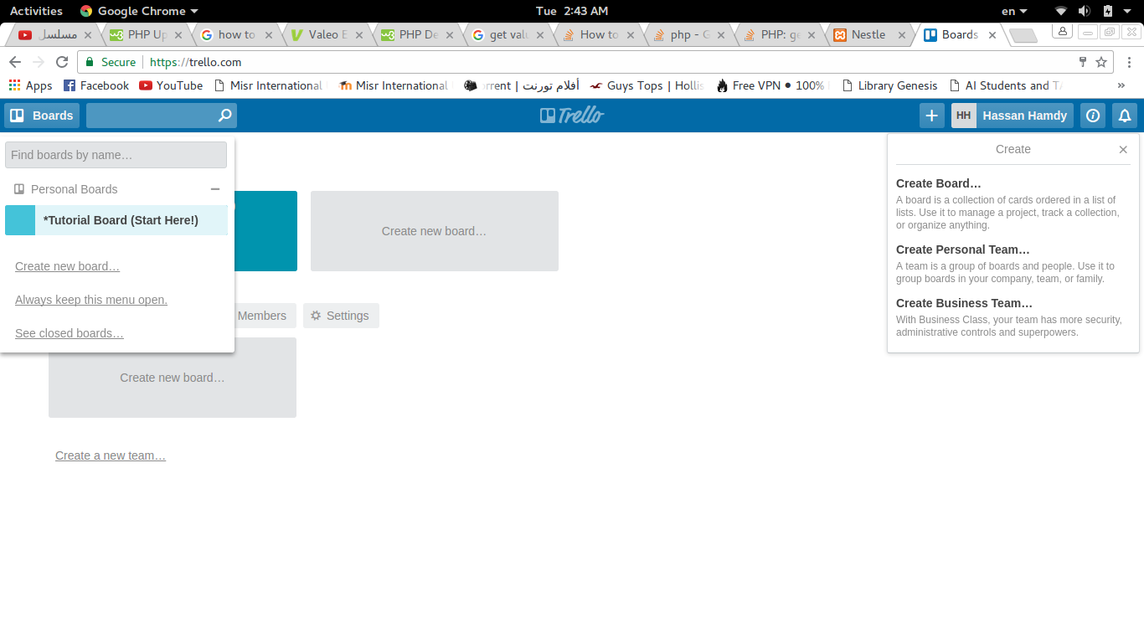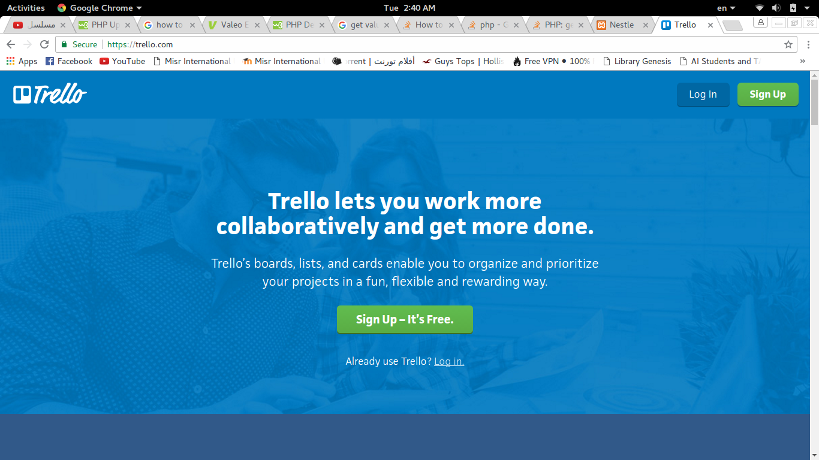

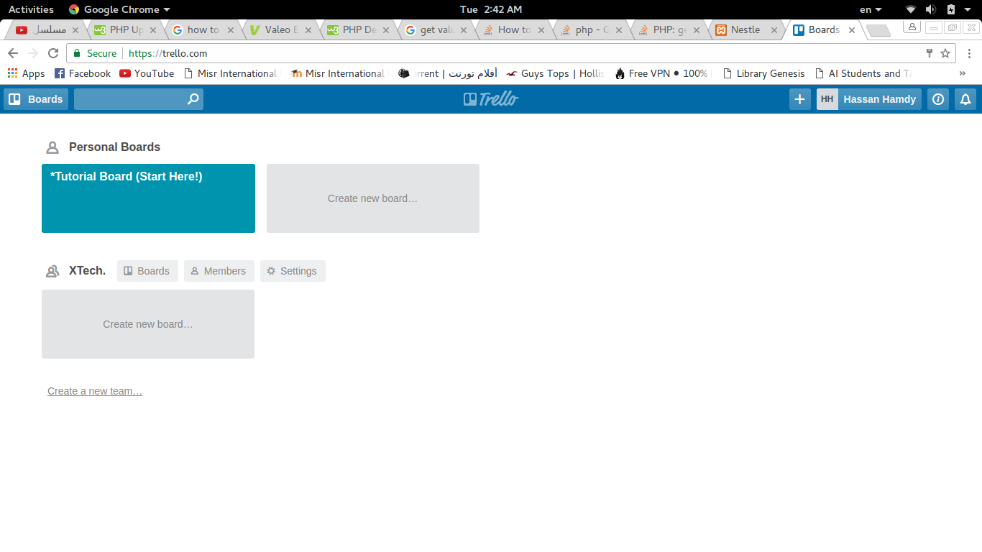



**2.3 User Characteristics**

**User use this system must know English, and know how to use web application as the audience will be using only web app.**

**2.4 User Objectives**

* **Team Leader: Wish to be connected easily with his team members, and give them the tasks or orders.**
* **Team Members: connect with each other’s if anyone has questions could ask his colleagues.**
* **Project Manager: He create projects and choose team leaders for each project.**

**3 Functional Requirements**

**The user view depends on the login according to usertype the functions will differ. Each user has priviliges; Admin, create accounts; Manager, create projects, choose team leader, budget and due date; Team leader, choose team members and receive tasks through due date; Team member, only notified when there are new task assigned and upload it when accomplished.**

**4 Interface Requirement.**

**4.1.1 Back-end**

* **Team leader.**

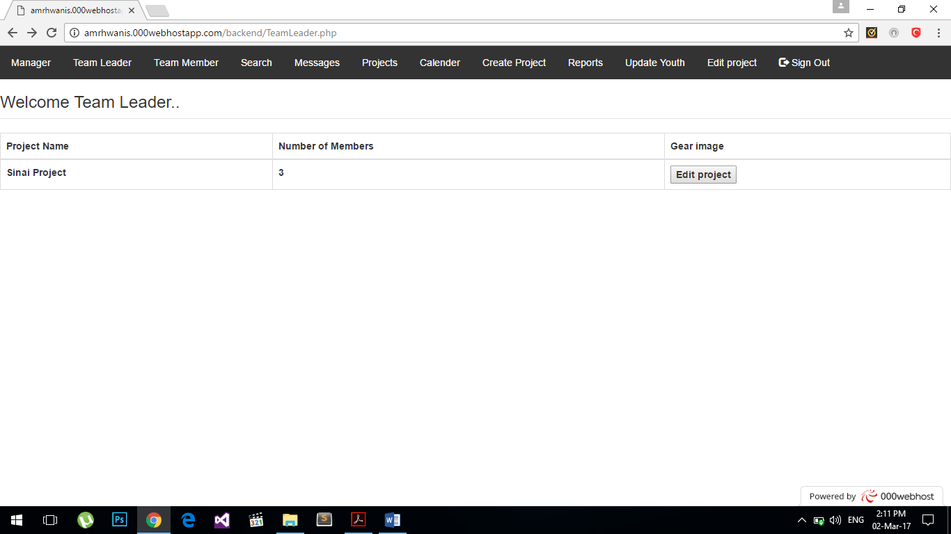

* **Team member.**

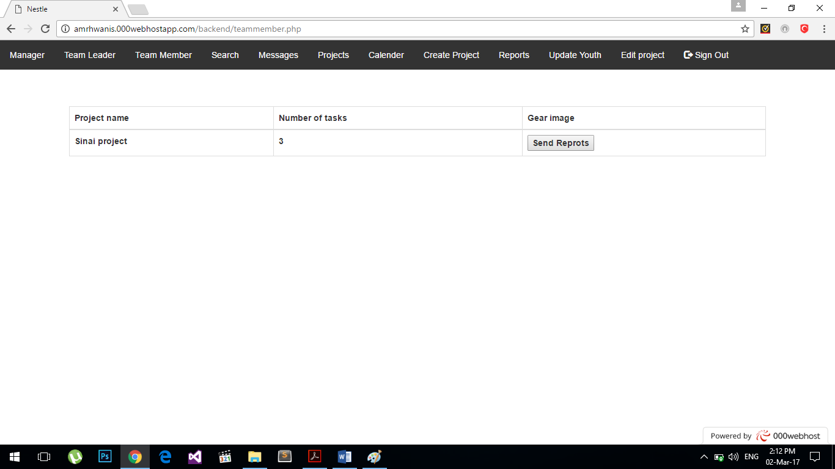

* **Create Projects.**

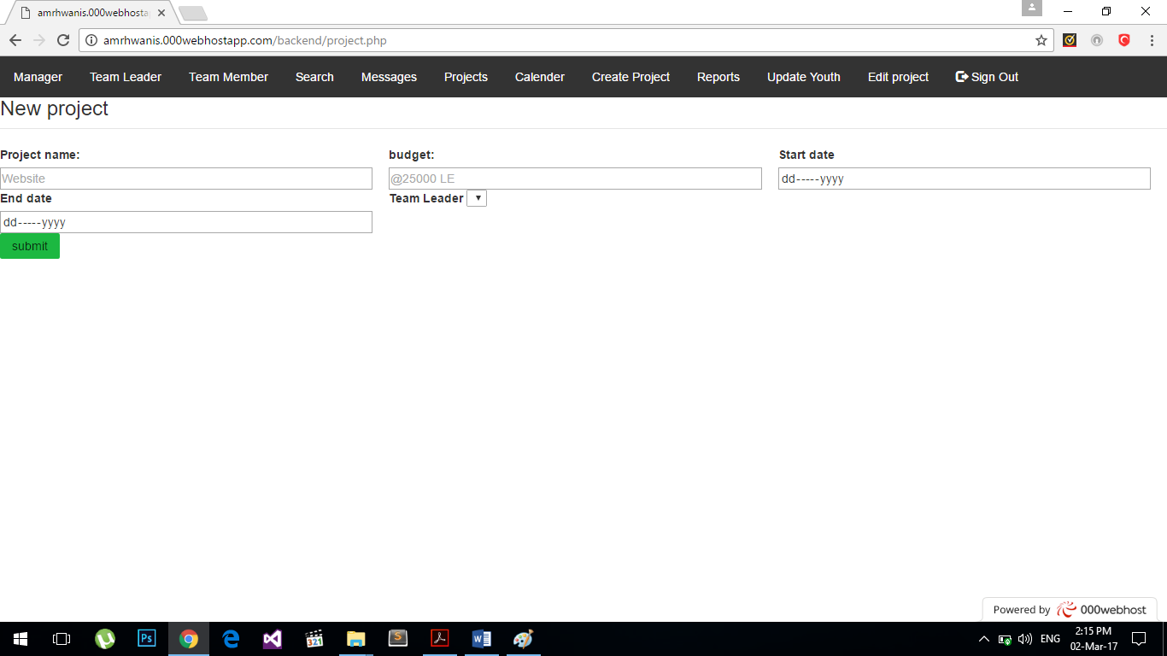

**4.1.2 Front-end.**

* **About Us.**

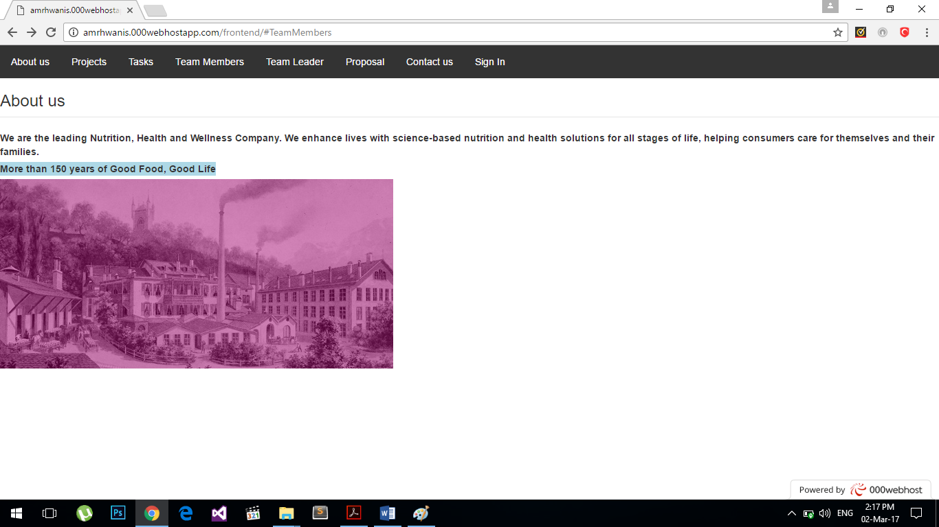

* **Projects.**

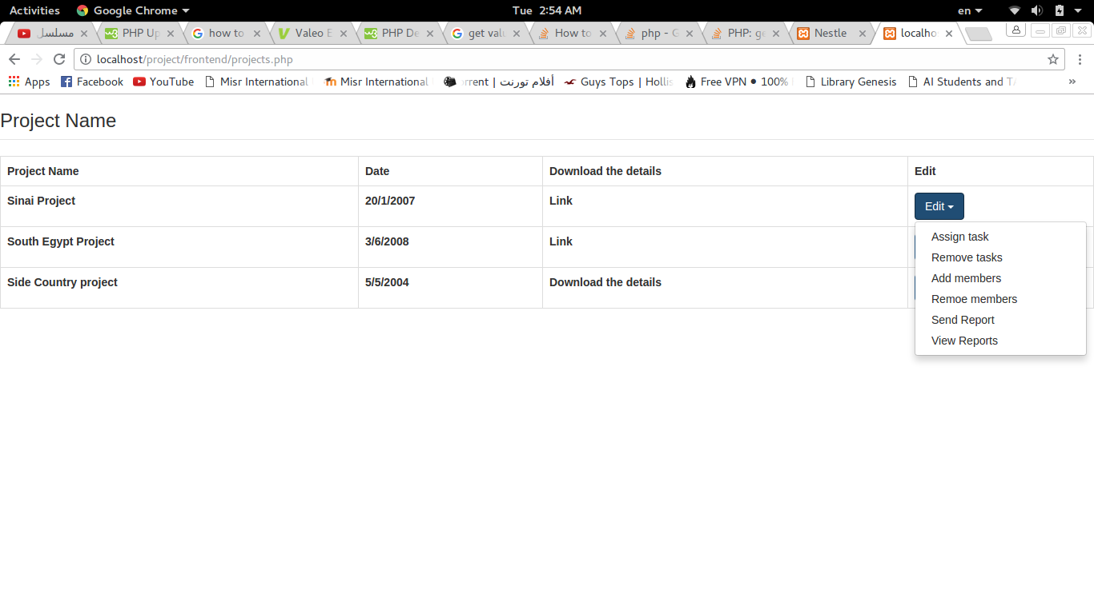

**4.1.3 API:**

**Google Calender API**

**4.3 Communications Interface:**

* **Database**
* **Web Browser**
* **Send Messages through E-mails**

**4.4 Software Interfaces:**

**We have software interfaces to make it easy to users outside the company to import their files such as excel files or word files to the database.**

**5 Performance Requirements**

**6 Design Constraints**

**6.1 Standards:**

* **IEEE standards**

**7 Other non-Functional attributes**

**7.1 Security:**

**The login of the user is encrypted of course to keep the users and decrypted in the login so the user data can be secured.**

**7.4 Maintainability:**

**The code can be maintainable easily since everything is made is setters and getters sot functions are easily made**

**7.5 Reusable:**

**Modules are common in the pproject so we can take modules form**

**8 Preliminary Object-Oriented Domain Analysis**

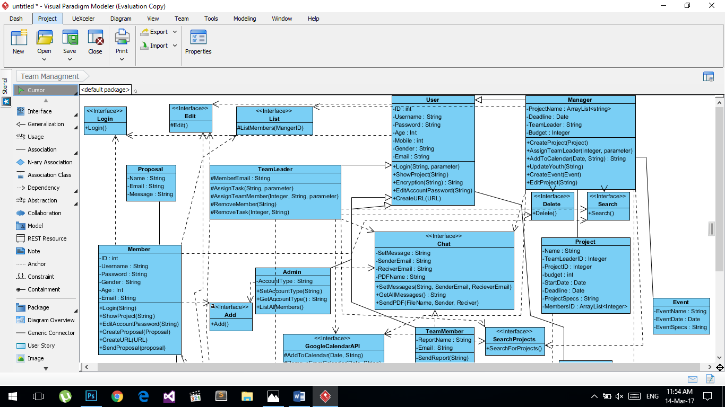

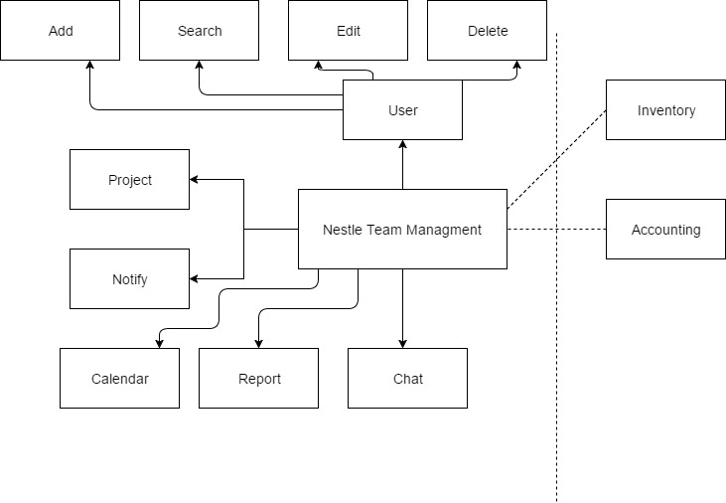

**9 Operational Scenarios**

**The user interface differ from admin, manager and member view. Admin can create new accounts. Manager perspective will see calendar and can put new events can be seen by team leader and members, receive finished tasks from team members. Team leader can view projects, choose number of team member, and choose due date. Proposal in back-end can change the proposal front-end page. Members get notified about tasks and upload tasks to leaders.**

**10 Preliminary Schedule Adjusted**

**Team Management web application, it’s provides service to managers and team leaders to finish their tasks with flexible and more technological way to assign projects. There are due dates to finish the tasks and notifications for both (members and leaders) when they finish the task or when new task had been assigned to member. The resources needed to use the web application are knowledge for English language, and interact with computers before to can insert data or read data from the system.**

**11 Preliminary Budget Adjusted**

**The project will cost zero pounds, due to its academic propose.**